DEVELOP A SIMPLE CALCULATOR USING XML-RPC
EXPT.NO:5
AIM: To develop a simple calculator application using XML-RPC in python where the server performs arithmetic operation (addition, subtraction, multiplication and division) or inputs sent from the clients.
ALGORITHM:
SERVER:
- Import simple XML-RPC (server from XML-RPC server).
- Define arithmetic functions (add, sub, mul, div)
- Create an XML-RPC server object with host part
- Register the function, with the server.
- Start the server.
CLIENT:
- Import XML-RPC client.
- Create a server Proxy object to connect to the server.
- Ask the user for the operation and input values.
- Call the approximate function through the proxy.
- Display the result received from the server.
CODE:
SERVER:
from xmlrpc.server import SimpleXMLRPCServer

# Define arithmetic functions
def add(x, y):
return x + y

def subtract(x, y):
return x - y

def multiply(x, y):
return x * y

def division(x, y):
if y == 0:
return "Error: Division by zero"
return x / y

# Create XML-RPC server
server = SimpleXMLRPCServer(("localhost", 8000))
print("XML-RPC Calculator Server running on port 8000...")

# Register functions
server.register_function(add, "add")
server.register_function(subtract, "subtract")
server.register_function(multiply, "multiply")
server.register_function(division, "division")

# Keep server running
server.serve_forever()

CLIENT:

import xmlrpc.client
# Connect to the XML-RPC server
proxy = xmlrpc.client.ServerProxy("http://localhost:8000/")
print("Simple XML-RPC Calculator")
print("Available operations: add, subtract, multiply, division")
# Get user input
op = input("Enter operation: ").strip().lower()
x = int(input("Enter first number: "))
y = int(input("Enter second number: "))

# Perform operation
if op == "add":
result = proxy.add(x, y)
elif op == "subtract":
result = proxy.subtract(x, y)
elif op == "multiply":
result = proxy.multiply(x, y)
elif op == "division":
result = proxy.division(x, y)
else:
result = "Invalid operation!"
print("Result:", result)

INPUT:
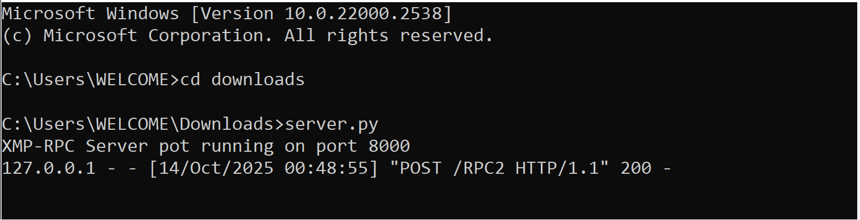

OUTPUT (from client side):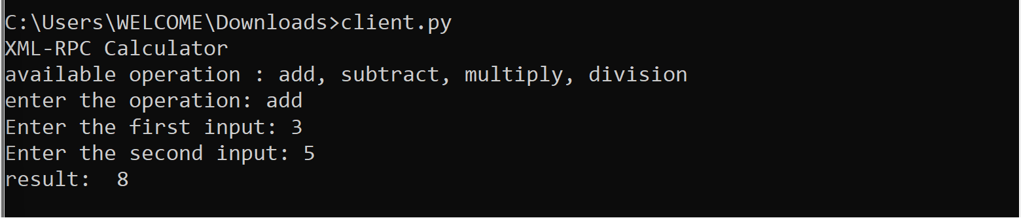

RESULT:
A simple calculator using XML-RPC in python is successfully developed and performed arithmetic operation.

